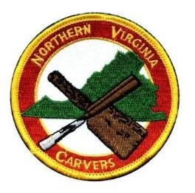
Membership Application
Name:____________________________________
Address: __________________________________
_________________________________________

Day Phone: _____________________________
Evening Phone: __________________________

E-Mail to receive newsletter and club information: __________________________________
Print Clearly
Carving Experience:
- Novice:
- Intermediate: ▪ Advanced:
Membership Fees Per Year:
Single $25.00
Family: $25.00 + $5.00 each additional member
MAKE CHECK PAYABLE TO NVC
MAIL APPLICATION WITH CHECK TO:
Bob Simoniz
6819 Rock Creek Court
Alexandria, VA 22306

Suggestions for programs or carving techniques: __________________________________________
_________________________________________________________________________________

