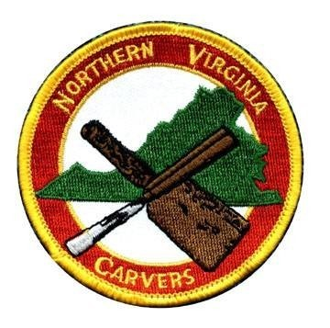
NORTHERN VIRGINIA

CARVERS

Web:
g
www.NorthernVirginiaCarvers.or

MARCH 2024 Issue
202
4
–

3

FROM THE PRESIDENT

JOYCE SPIELER

President’s Letter
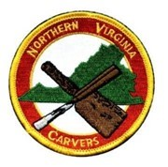
OH! Where do I begin…. In one of my previous letters I had shared my dreams for the Northern Virginia Carvers.

With the spirit of those dreams many club members have stepped up to have some of those dreams realized. Membership participation, articles for the newsletter, taking carving classes, sharing carving with the younger generation, and so much more.

I want to thank all of you.

This is only the beginning of our adventures. Every newsletter is filled with people to know, things to do and places meet. Continue to add to the club, and the newsletter. This will excite others to join our carving club. Which, actually it has.

Joyce Spieler
President
Northern Virginia Carvers
NORTHERN VIRGINIA CARVERS

WEB SITE UPDATED

VISIT

https://northernvirginiacarvers.org/

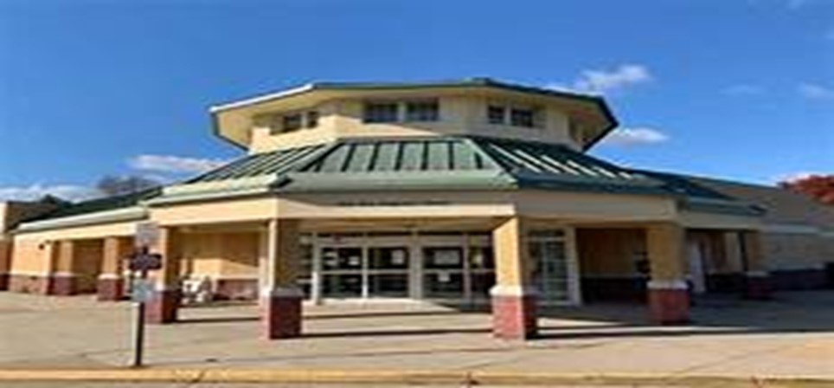
Bull Run Library Maker Faire

Below is an e
-
mail From Delwyn whom works at the Bull Run Library.

Delwyn “is reaching out to let you know about our first annual
Bull Run Library Maker Faire
. As you know our
branch is fortunate to have a busy makerspace full of fabulous machines and tools. We have so many patrons who
are

ready for the next level of making, and are looking for groups to join and people to meet. The
Maker Faire

will
take place at our library on
June 22
^{nd}
, which coincides with the National Week of Making (June 17
-
23, 2024).

We

are inviting local guilds of all kinds to participate and very much hope that your group of carvers would like to get
involved. During the faire, our library and grounds will also be buzzing with a craft market, book sale, petting zoo, a
mobile library bus, and a range of maker activities that will appeal to a variety of ages and skill levels. The day will be
a celebration of local crafters, artists,

and makers.

As a participant,

you will be set up inside in the 'Guild Hall' alongside other artisan and craft guilds, giving you

an op-
portunity to connect with other crafts people in the area. We hope that the event will introduce our community to
guilds in the area that they may like to join. As well as a
membership

drive, this event will be an opportunity to show-
case master craftspeople and the activities of your group.”

The Northern Virginia Carvers would like to have a representation for the club. We have one volunteer that has
signed up to represent us. I think it would be great to have
one

more person to accompany
Michael W. Bring
in

more club members
!

Achievements of a Life Time
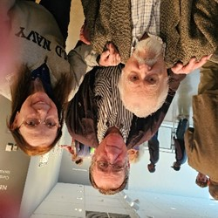
Below is the invitation to a showing of Joel Jacobson’s (a long-time member of the Northern Virginia carvers) photography along with an acknowledgement of the mission of Topper Carew’s vitalizing of Adams Morgan community. Joel was monumental in the progress in this community of under realized persons. Persons also involved where well know artists like Stevie Wonder, and Roberta Flack.
Michael Connors and I traveled to Katzen Arts Center to share this photographic works exhibit accomplished by Joel Jacobson.
“FRIDAY, FEBRUARY 9 at AFI Silver Theatre
Debut screening of Topper Carew’s recent documentary on The New Thing (2024) followed by his newest film This Little Light of Mine (2023), which features performances of children’s choirs across the world and will be sent to the Space station for transmission back to the world. There will be a Q & A with Topper Carew followed by a screening of his first film project, the full-length film DC Cab (1983)
SATURDAY, FEBRUARY 10 at Katzen Arts Center, American University
Gallery Talk/Panel Discussion with Topper Carew, photographers Joel Jacobson, Tom Zetterstrom, and Anacostia Community Museum director Samir Meghelli.
Opening of photography exhibit at Katzen Arts Center.
The photography exhibit has been made possible through the generous support of the JacksonReed High School’s PTSO, the Anacostia Community Museum, the DC History Center, and the Digital Media Academy at Jackson-Reed.”
The panel discussion spoke to me personally. This stemmed from my childhood as well as my role as President of the Northern Virginia Carvers.
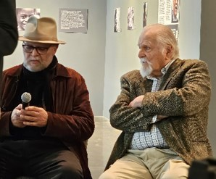
Statements from the Topper Carew, Joel Jacobson, Tom Zetterstrom and Samir Meghelli included:
Team work makes the dream work
Perspective changes the long road
No project too big to tackle together
Empower the people – organize people
Grassroots base organizing
Being loud and making others in the know
Stronger than you think you are
Strengthen democracy vision
“The New Thing” is a mission that is continuing to revitalize community young and old. My experience with the panel discussion and the photography exhibit energized the spirit in me to draw from that day to my work with the Northern Virginia Carvers. CONGRATULATIONS JOEL!!!!!
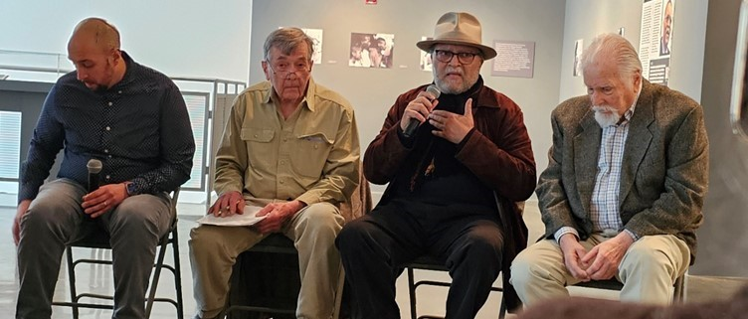
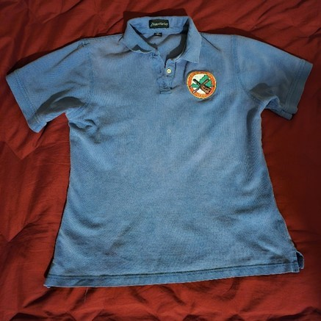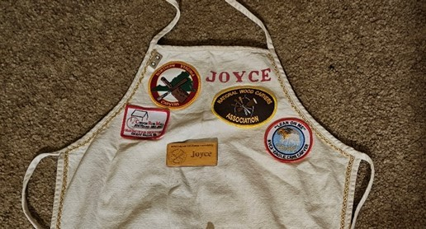
Patches, and Club Shirts

The club has re
-
established our relationship with All Stars Sports for fabrication of club patches and shirts
with patches. To have our club patches on our aprons or shirts is a good way to show unity and pride in
our club at community activities, meetings and carving events.

Contact Joyce if you are interested in purchasing patches with or without shirts. Details depend on what
kind of response there is from the club members.

Moonbeam4mj
-
carver@yahoo.com

or text 703
-
915
-
3239

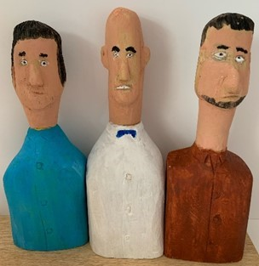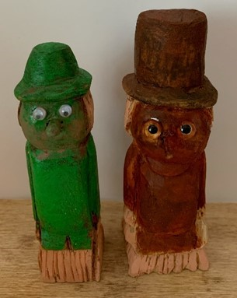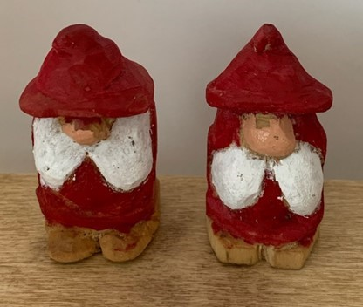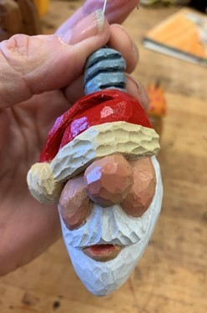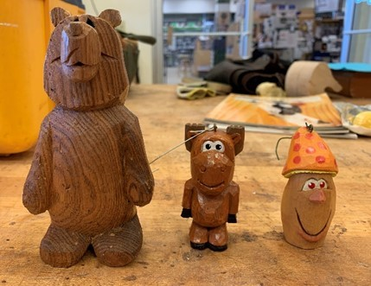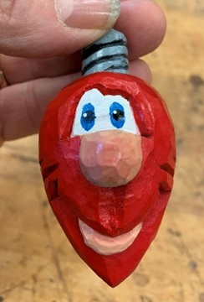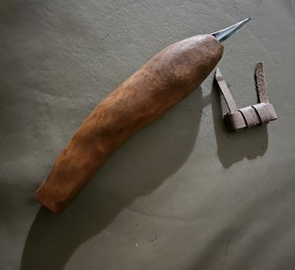
SHOW & TELL

Les T

Ernie M

SCARECROW

GNOMES

Joyce S

Dressing Table/Low Boy
By Dwight Carmon

There are many different carving projects such as birds, caricatures, relief, fish, and others; each as important as the next. Furniture is one of my interests.

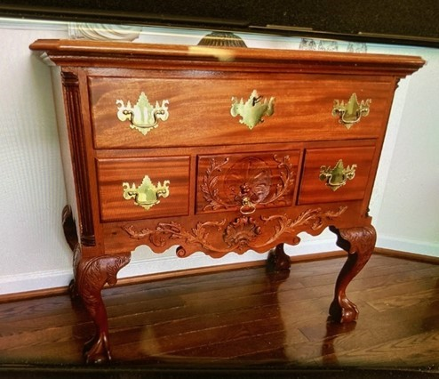
The Dressing Table/Low Boy pictured above is the result of taking carving classes conducted by George Slack at the Woodcraft store when it was at Commerce Street. Those classes focused on early American furniture. The Diplomatic Reception Room at the Secretary of States Office in Washington, D.C. has many original pieces of such furniture from the 1700s by the original artists like John Goddard and John Townsend. This is where the original of the table pictured here is currently located. It can also be seen in the book, “Treasures of State” page 100. That was the inspiration for making this copy.

The piece is 30” high by 36” wide and 21 ½” deep. The primary wood is mahogany. Other parts of the piece, such as the drawer interiors and glue blocks are white pine. All parts are solid wood (no glue ups) in the original and my copy. The original was made about 1755-1775 in Philadelphia.

The carvings on the apron are glued on while the bottom center drawer is carved into the drawer front. Since there were no router bits that matched the top’s profile, I carved it by hand with a hand plane and gouges. The legs were carved from 3” X 3” X 29” solid mahogany. The fluted quarter columns are inlet into the upper portion of the leg blank. The columns were made by gluing four 1 ¼” square pieces together with paper and hide glue, then turned on a lathe. Flutes were carved using a 9/5 gouge while using the indexing setup on the lathe for spacing. By carefully using a flat chisel, each of the four pieces were then separated and then I used the two best ones on the final product. Brasses are from Ball and Ball.

Other than a bandsaw, lathe, and table saw for rough shaping the rest of the piece was carve by hand. I have no idea how long it took me to make the piece since it was a stop-and-go process over several years. I was lucky to have some large Honduran mahogany boards. Wood used in this project ranged from 16 quarter for the legs to 5 quarter for the sides, draw fronts, and top which means I didn’t have to glue up anything. Over 23 years none of my furniture has warped or has split boards.

I have made other pieces such as a tall case clock, side tables, tilt top and rectangular tea tables, corner chairs, side chairs, footstools, and serving trays. Other projects. In-the-works, include a kneehole desk a partner’s desk, and a Peter Scott tea table.

As a side note, In the process of making these projects I have acquired many gouges, chisels, and other woodworking items, some of which turned out to be unnecessary. I am happy in the knowledge that it is rare people have fallen in to this trap like I did.

I have found carving to be relaxing and fulfilling as well as a way to meet some good friends and really talented people.

TIME TO RENEW YOUR MEMBERSHIP  FOR 2024 | NORTHERN VIRGINIA CARVERS RENEWAL  FOR JAN-DEC 2024  Name___________________________ Address:  ________________________________  ________________________________  ________________________________  Home Phone_____________________  Cell Phone_______________________  Receive Newsletter by E-Mail?  Yes______ No_______  E-Mail___________________________  Membership Fees Per Year:  Single $25.00  Family: $25.00 + $5.00 each additional member  Additional members names:  ________________________________  ________________________________  Suggestions for Programs or Classes  ________________________________  ________________________________  ________________________________  MAKE CHECK PAYABLE TO NVC AND MAIL TO:  Robert Simoniz, Membership  NORTHERN VIRGINIA CARVERS  6819 Rock Creek Court Alexandria, VA 22306
Membership in the Northern Virginia Carvers runs from January to December. Please mail your dues, which are $25.00 for a single membership and $5.00 for each additional family member along with the filled out renewal form, to Robert Simoniz, Membership Chairman, 6819 Rock Creek Court, Alexandria, VA 22306. Make check payable to NVC.

If you have changed your email, please let us know. If you used to get the newsletter by email, but recently have received mailed copies, then something is wrong with the email address we have on file for you, and your email copy bounced back. Please contact Bob Simoniz at rsim2193@veriizon.net, so he can correct the database.

DEADLINE FOR APR. NEWSLETTER ARTICLES: FRIDAY MAR 29
DIRECTIONS:
Woodcraft Supply — Ravensworth Shopping Center, 5248 Port Royal Road, Springfield, VA 22151. 703-912-6727.
From I-495 take Braddock Rd Exit 54A west. Ravensworth Shopping Center is at the intersection of Braddock Road
American Legion Post 176 (carving classes)— 6520 Amherst Avenue, Springfield, Virginia 22150. From Springfield driving East on Old Keene Mill Road to Springfield Blvd. just past Veterans Bridge, turn right and proceed to the Post parking lot on the right. From Springfield driving West on Franconia Road, passing under I-95 to Bland Street just past Shoney's Restaurant, turn right onto Bland Street and proceed to Amherst Avenue. Turn right onto Amherst Avenue and proceed over Veterans bridge. The Post is on the right, before Kay Jennings Toyota at the foot of the bridge.
Packard Center — 4022 Hummer Road, Annandale, VA 22003. From I-495 take Little River Turnpike East and turn left at the first light onto Hummer Road. Just past the small shopping area less than 1/4 mi on the left will be signs for the center. Turn left into the drive and bear right when it forks. The evening entrance for meetings is on the side of the building on the parking lot side. The meeting area is in the conference room in the basement.
 |  | NVC Contacts
President | Joyce Spieler | Chairs General Meetings and Board Meetings | Moonbeam4mj-carver@yahoo.com | 703-915-3239
Vice-President | Mark Tranchemontagne | Vice Chair of General Meetings and Board Meetings | mgtranch@yahoo.com | 703-531-9912
Treasurer | Kristen Gaulin | Manages Finances | kgaulin1983@gmail.com | 813-526-1851
Secretary |  | Keeps Minutes and Maintains NVC Archives
Past President | Phillip Simpson |  | eightb1045@aol.com | 703-360-9575
Colvin Mill Coordinator Joyce Spieler |  | Coordinates Carving Instruction Program at Colvin Mill Park | Moonbeam4mj-carver@yahoo.com | 703-915-3239
Show Coordinator |  | Coordinates the Annual Show & Competition
Membership Chairman and  Newsletter Editor | Bob Simoniz | Maintains membership database and collects dues Edits and publishes NVC Newsletter | rsim2193@verizon.net | 703-768-1087
Program Chairman |  | Develops New Programs for the Club
NVC Web Site | Joyce Spieler | www.northernvirginiacarvers.org | Moonbeam4mj-carver@yahoo.com | 703-915-3239
Member-at-Large  Member-at-Large  Member-at-Large | B J France  Jerry Donahoe  Michael Wine |  | bjinarl@aol.com  jrdsriding@aol.com  mdwine55@gmail.com | 703-538-4143  703-327-4022  703-368-2282
NORTHERN VIRGINIA CARVERS  6819 Rock Creek Court Alexandria, VA 22306 |  |  | Address Correction Requested

