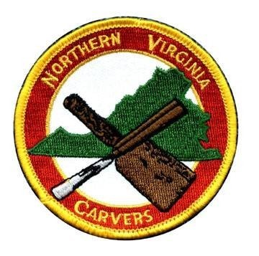
NORTHERN VIRGINIA

CARVERS

Web:
g
www.NorthernVirginiaCarvers.or

APRIL 2024 Issue
202
4
–

4

FROM THE PRESIDENT

JOYCE SPIELER

President’s letter April 2024
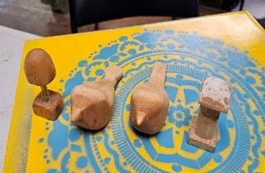
Comradery. It seems that the Northern Virginia Carvers (NVC) have joined forces with the Montgomery County Carvers (MCC) for years now. There have been Zoom meetings during Covid times to keep the lines of communication going. Then we transitioned to blended sharing. As the schedule evolves there are now opportunities to join MCC and or NVC. The newsletter is a great way of communicating to each other. Send your stories, activities and questions to me for them to be included in the newsletter that is sent out to everyone in our club.
Read through every newsletter for the calendar of events and opportunities.
Place these in your calendar for a good reference and a reminder for yourself. Thank you,
Joyce Spieler
President
Northern Virginia Carvers
Moonbeam4mj-carver@yahoo.com
703-915-3239
One person can make a difference, and everyone should try. John F. Kennedy
Volunteers Needed
Colvin Run Mill April 21 AND April 19 – for set up
Web Master – update web site every month on current web site
Program coordinator – provide ideas, assist w/ procuring teachers/speakers/classes available
Provide list of up and coming events outside of club events
Packard Center consistent opener – if afternoons are requested 3:30 +
Let Joyce know if you are interested in carving in the afternoons
Artisans United representative – 3rd Monday evening Zoom – 7:00 pm to 8:30 pm
Summer Picnic – June 29, 2024 – committee – formation needed
2024 Show and Competition – committee - formation needed DATE: October 26, 2024
(approved by Woodcraft already)
2024 December X-mas party – committee - formation needed
Send Joyce an e-mail or text if you are interested in any of these volunteering opportunities. Moonbeam4mj-carver@yahoo.com or 703-915-3239
THANK YOU IN ADVANCE!
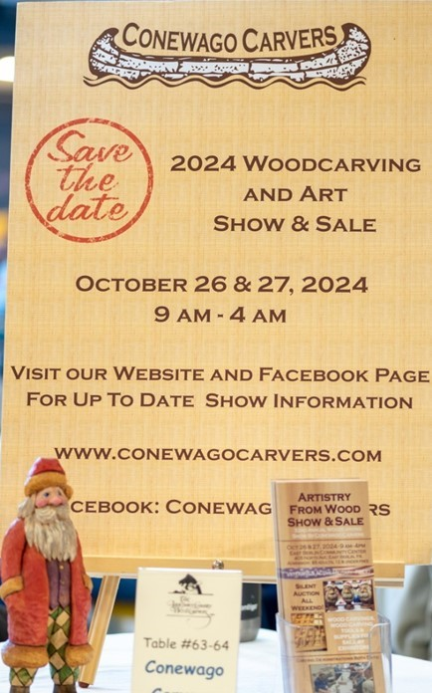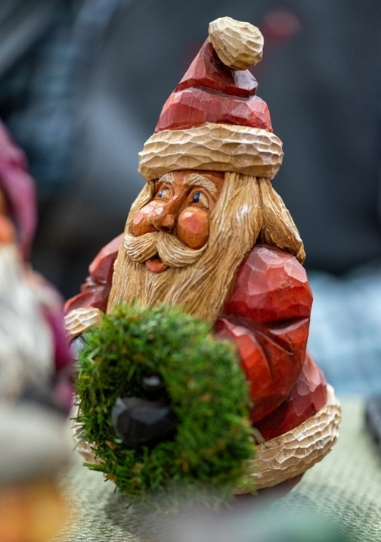
“WONDERS IN WOOD”

BY Michael Wine

Here are a few images from the "Wonders in Wood" carving show produced by the Lancaster County
Wood Carvers March 15 and 16, 2024. Jim Feather of Caricature Carvers of America (CCA) was the
featured carver, who also conducted a 2
-
day class on the Monday and Tuesday following the show. I just
discovered that Joe You (CCA) will be the featured carver in 2025!! Very exciting indeed!!

The weather outside was chilly, but that did not deter nearly 700 people from attending the first day.
This year there were four CCA carvers in attendance!

The show features a variety of styles and subjects, from cartoon caricatures to duck decoys, wildfowl and
cartoon whimsy. Other artists feature woodburning, painting on wood and others weaving pine needles
into beautiful and varied vessels.

While the show is a bit of a drive from Northern Virginia, at approximately 2.5 hours driving leisurely, it
is well worth a day trip or even a weekend getaway.

I would be remiss if I did not mention how lovely everyone is at the show. I didn't hear a cross word all
weekend, except when my own camera misfunctioned! The carvers and the visitors make the show an
extremely pleasant experience.

I've selected some of my favorite pictures from the show. My apologies to the creators and carvers as my
equipment misfortune threw me off my game. I'll post all the images to Flicker and provide a link to
them next month through the club to the membership newsletter once the carvers have had their chance
to download and use the images. (Please do not repost images without express permission.)

The Shameless Plug:
The Conewago Carvers will produce their own show
in nearby East Berlin, Penn-
sylvania. This one is a bit closer at approximately 1.5 hours and many of these same exhibitors and carv-
ers will be there as well. Another great opportunity to see a display of fabulously talented artisans and
their work.

Carvers of America

cca
-
carvers.org/

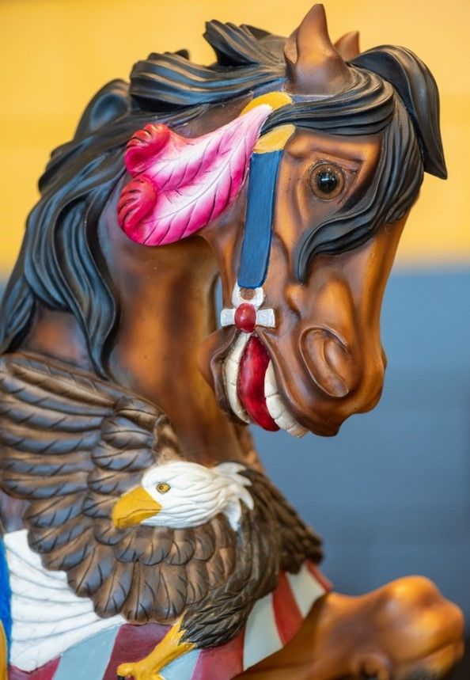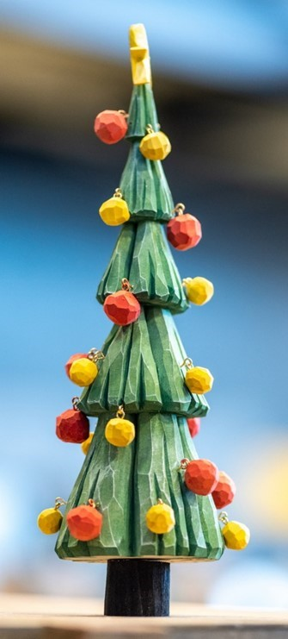

Lancaster County Wood Carvers

www.lancarvers.com/

Conewago Carvers

www.conewagocarvers.com
/

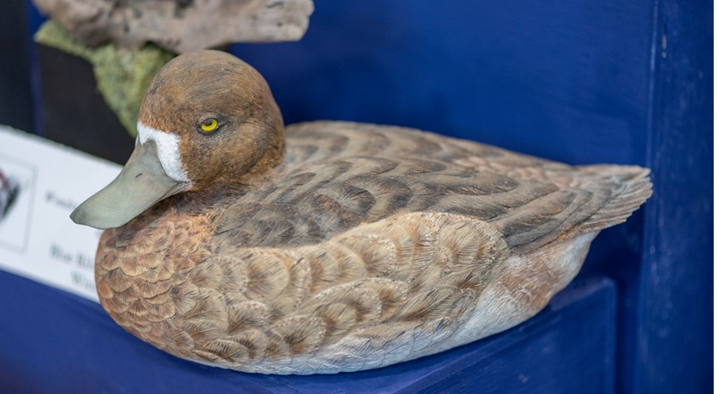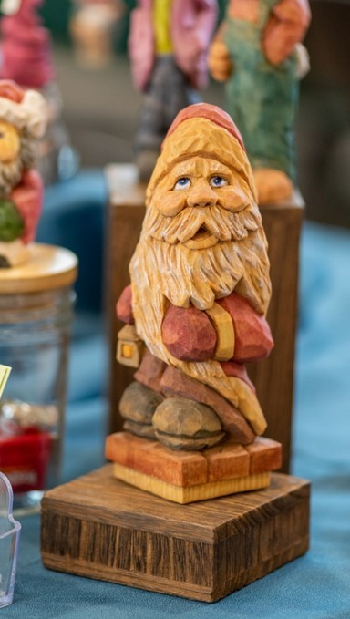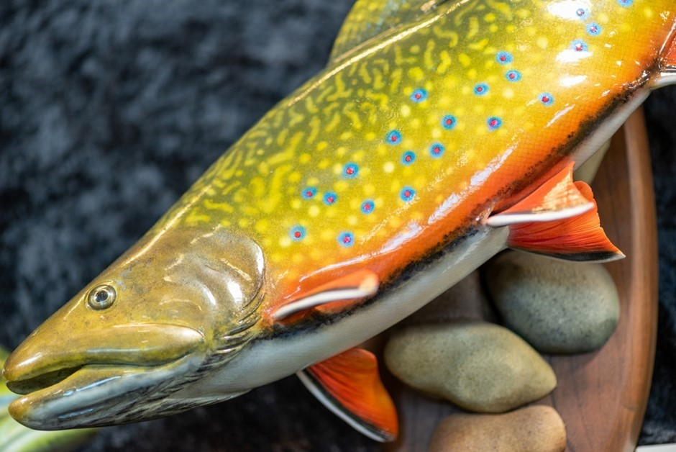

Photos taken by Michael Wine.

NORTHERN VIRGINIA CARVERS RENEWAL
FOR JAN-DEC 2024

Name___________________________ Address:
________________________________

________________________________

________________________________

Home Phone_____________________

Cell Phone_______________________

Receive Newsletter by E-Mail?

Yes______ No_______

E-Mail___________________________

Membership Fees Per Year:

Single $25.00
Family: $25.00 + $5.00 each additional member

Additional members names:
________________________________

________________________________

Suggestions for Programs or Classes
________________________________

________________________________

________________________________

MAKE CHECK PAYABLE TO NVC AND MAIL TO:

Robert Simoniz, Membership
NORTHERN VIRGINIA CARVERS
6819 Rock Creek Court Alexandria, VA 22306

Membership in the Northern Virginia Carvers runs from January to December. Please mail your dues, which are $25.00 for a single membership and $5.00 for each additional family member along with the filled out renewal form, to Robert Simoniz, Membership Chairman, 6819 Rock Creek Court, Alexandria, VA 22306. Make check payable to NVC.

If you have changed your email, please let us know. If you used to get the newsletter by email, but recently have received mailed copies, then something is wrong with the email address we have on file for you, and your email copy bounced back. Please contact Bob Simoniz at rsim2193@veriizon.net, so he can correct the database.

Calendar APRIL 2024
Monday April 1, 2024 Woodcraft 3-6 pm

Sunday April 7, 2024 Colvin Run Mill 12-3 pm

Monday April 8, 2024 Woodcraft 3-6 pm

Thursday April 11, 2024 Zoom Open carve

Monday April 15, 2024 Woodcraft 3-6 pm

Sunday April 21, 2024 Colvin Run Mill 12-3 pm

Monday April 22, 2024 Ridhard Byrd 3-6 carve only and Packard Center 6:30- 9 pm carve + business

Thursday April 25, 2024 Zoom Project Carve 7-8 pm

Monday April 29, 2024 Richard Byrd 3-6 pm

 | DEADLINE FOR MAY NEWSLETTER ARTICLES: FRIDAY APR 26
 | MEETING LOCATIONS
Woodcraft Supply — Ravensworth Shopping Center, 5248 Port Royal Road, Springfield, VA 22151. 703-912-6727.

American Legion Post 176 -- 6520 Amherst Avenue, Springfield, Virginia 22150.

Packard Center — 4022 Hummer Road, Annandale, VA 22003.

Richard Byrd Library – 7250 Commerce St, Springfield, VA 22150

Kings Park Library, -- 9000 Burke Lake Rd, Burke, VA 22015

Colvin Run Mill,-- 10017 Colvin Run Rd, Great Falls, VA 22066-1834

 |  |  | NVC Contacts
President |  | Joyce Spieler | Chairs General Meetings and Board Meetings |  | Moonbeam4mj-carver@yahoo.com | 703-915-3239
Vice-President |  | Mark Tranchemontagne | Vice Chair of General Meetings and Board Meetings |  | mgtranch@yahoo.com | 703-531-9912
Treasurer |  | Kristen Gaulin | Manages Finances |  | kgaulin1983@gmail.com | 813-526-1851
Secretary |  |  | Keeps Minutes and Maintains NVC Archives
Past President |  | Phillip Simpson |  |  | eightb1045@aol.com | 703-360-9575
Colvin Mill Coordinator Joyce Spieler |  |  | Coordinates Carving Instruction Program at Colvin Mill Park |  | Moonbeam4mj-carver@yahoo.com | 703-915-3239
Show Coordinator |  |  | Coordinates the Annual Show & Competition
Membership Chairman and  Newsletter Editor |  | Bob Simoniz | Maintains membership database and collects dues Edits and publishes NVC Newsletter |  | rsim2193@verizon.net | 703-768-1087
Program Chairman |  |  | Develops New Programs for the Club
NVC Web Site |  | Joyce Spieler | www.northernvirginiacarvers.org |  | Moonbeam4mj-carver@yahoo.com | 703-915-3239
Member-at-Large  Member-at-Large  Member-at-Large |  | B J France  Jerry Donahoe  Michael Wine |  |  | bjinarl@aol.com  jrdsriding@aol.com  mdwine55@gmail.com | 703-538-4143  703-327-4022  703-368-2282
NORTHERN VIRGINIA CARVERS  6819 Rock Creek Court Alexandria, VA 22306 |  |  |  |  | Address Correction Requested

