April
2024
Meeting Schedule
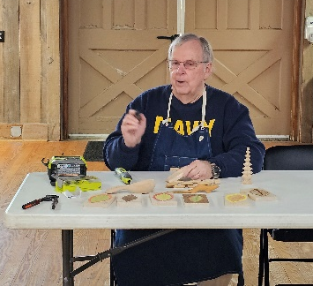
Todd teaching at Colvin Run Mill through Parktakes

 | Northern Virginia Carvers
Sunday |  | Monday | Tuesday | Wednesday | Thursday | Friday | Saturday
 |  | 1 | 2 | 3 | 4 | 5 | 6
 |  | Woodcraft 3-6 pm
7 |  | 8 | 9 | 10 | 11 | 12 | 13
Colvin Run Mill 12-3 pm |  | Woodcraft 3-6 pm |  |  | Zoom Open Carve 7-8 pm
14 |  | 15 | 16 | 17 | 18 | 19 | 20
 |  | Woodcraft 3-6 pm
21 |  | 22 | 23 | 24 | 25 | 26 | 27
Colvin Run Mill 12-3 pm |  | Richard Byrd 3-6 pm  Packard Center 6:30-9 pm |  |  | Zoom Project Carve 7-8 pm
28 |  | 29 | 30
 |  | Richard Byrd 3-6 pm
Woodcraft meetings are on the 1st and 3rd Mondays of each month. 3-6 pm. Grace will fill in the calendar on the other Mondays from month to month. Packard Center evening meetings are on the 4th Monday of each month.

