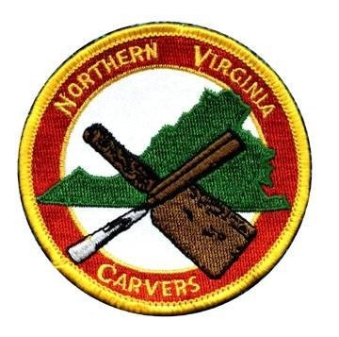
NORTHERN VIRGINIA

CARVERS

Web:
www.NorthernVirginiaCarvers.or
g

MAY 2025 Issue 20
25
–

5

FROM THE PRESIDENT

JOYCE SPIELER

President’s Letter

Hello Carvers,
As all of you probably noticed this newsletter is definitely in May. I occasionally take a break from my usual duties. With the club and also in my other life’s duties. Everyone is entitled.

I have so much to share with you. The club is growing slowly but surely. As we put ourselves out to the public to make them aware of our wonderful craft. The club is now able to pare down the number of meeting days. Mondays are the focus. For Mondays we have the Woodcraft Store, The SHED, and the Packard Center. Thank goodness for my phone calendar. Also, if you have availed yourself of the Montgomery County Carvers in-person or Web based meetings that is a wealth of carving experiences available on first and third Thursdays. I send out their announcements. Please read those informative e-mails.

At the last “SHED” meeting I attempted to have a carving session from a YouTube video on a “How to Whittle a Simple Christmas Tree” let’s say there is a lot of improvement needed on my part to share a new carving project. I am still working on development of our carving skills for the club. I have more ideas and would love to have a committee to investigate programs for our “SHED” meetings. Let me know because we can balance our club learning exposure from beginning to advanced. If you would like to see the tree project, go to DYWOODCARVING on YouTube.

This Christmas tree project is a lead in to The National Wood Carvers Ornament Contest. Clubs all across the country will send in carved Christmas ornaments. Entry labels are in the following pages of the newsletter. There is no need to worry about competing. Send in an ornament to be delivered to a needy person/ family. The simple Christmas tree can be sized how you want. We will have a tree eyelet and painting project during the May SHED meeting night. Thanks to Michael W. for leading the eyelet project. Bring your ornament or any project you have wanted to paint in your project pile. You can bring your own supplies or use the limited supplies I will have on hand. Contact me if you have any questions. If you want to pre-seal your piece, feel free. I will be trying out a new sealing technique. But, to tell you the truth not every carving needs sealing. Come to the SHED and discover.

May 26, 2025 Packard Center project will be a heart. This is a time specially geared towards a beginning class of students from the Annandale area. Feel free to come that evening from 6:30 pm to 9 pm. Bring your own project to work on for an open carving session as well.

It is time to continue to revamp the Colvin Run Mill supplies. I have mentioned this previously. Wendy and Ed kindly went through the huge supply of Go-Byes. There were many duplicates. I am offering these up for our club members. If they do not find homes, there is a charity project the carvings will be donated to.
Please speak up. I will have the box of carvings at the SHED meeting. That’s All FOLKS, Happy Carving!
Joyce Spieler
President
Northern Virginia Carvers
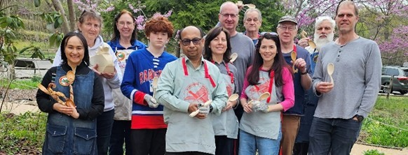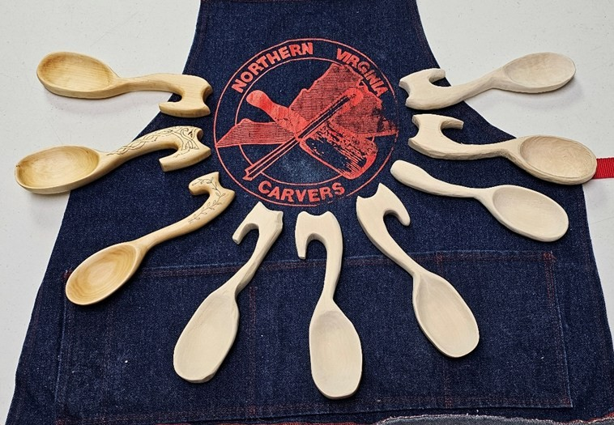
Parktakes Class
–

Spring 2025

(
Fairfax County Parks and Recreation
)

Spring of 2025 Parktakes class has now been completed. The class extended over three Sundays at Colvin
Run Mill. It was a great setting for the beginning woodcarvers experience.

There were eight students. Mostly adults were attending. The thing mostly impressive is family and
friends were gathering to share in the experience of wood carving.

The project of the class was a push
-
pull oven spoon. This project had many challenges. The curve of the
handle gave students the ability to work with many changes in grain. The spoon portion provided visuala-
tion of shape and contour to the students liking.

There were mixed levels of carving experience in the class. This gave sharing of experiences free flowing
throughout the sessions. Speaking of sharing of experiences
…
I had a wonderful group of volunteers for
the class. Thanks to John L. (from Montgomery County Carvers), Michael W., BJ F. Todd A
-
C and Phu-
ong
-
Anh N they brought their unique talents to share. Thanks to all of them for providing a diverse and in
-
depth experience for the students

GO-BYES ARE GOING GOOD BYE
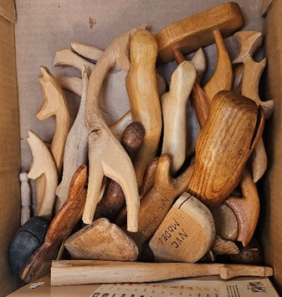
For many years we have stored many GO-BYES for carvers to use while carving at Colvin Run Mill. We are cleaning and reducing the inventory at the mill. I would like to offer Go-Byes that we no longer need to club members. Wendy N. and Ed D. graciously went through the old go-byes. If the unneeded items are not taken home by the club members, the go-byes will go to a charitable organization. The gobyes will be available at the SHED meeting May 19, 2025 and also request to Joyce are accepted. Please let me know by July 28, 2025. I
will have them at the Packard Center as well on the 1,2 and 4th Monday evenings. Moonbeam4mj-carver@yahoo.com
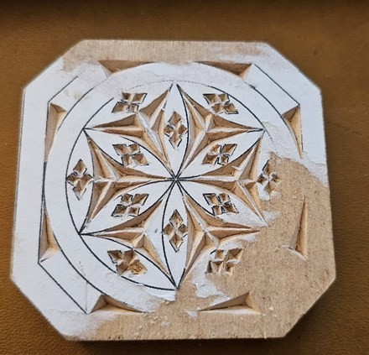
CONOWAGO CHIP CARVING CLASS LOOKING FOR MORE STUDENTS

From: Gary Peiffer

From: gmpeiffer@aol.com

Joyce

A reminder that you are signed up for the Don Karnas
Beginning Chip Carving class on June 21 at the East
Berlin Community Center in East Berlin PA.

Since we
are roughly close from the start of the seminar.

Some of you may already know Don who has taught
Chip Carving seminars at our club for a number of
years and his seminars are consistently both educa-
tional and entertaining.

As well, if you know of anyone that may be interested
in taking this course, feel free to let them know as we
can take up to four more students in this class and
the more students, the more chips that fly!

t

Gary Peiffer

CONOWAGO carvers

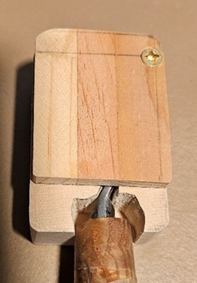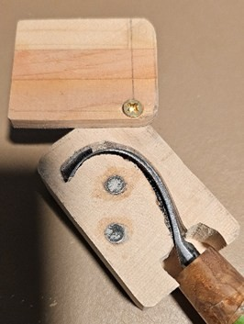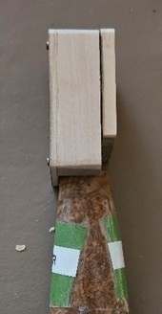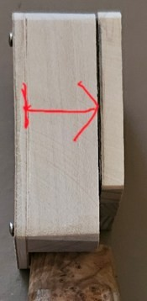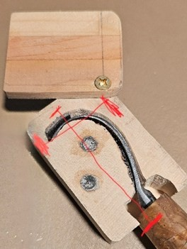
MAKE A HOOK KNIFE WOODEN SHEATH

When:

June 09, 2025 Monday PROJECT NIGHT

Time:

6:00
PM to 9:00 PM If afternoon works better let me know to see if room is available.

Where:

PACKARD CENTER

RSVP
–

SO THAT WE HAVE ENOUGH SUPPLIES FOR EVERYONE. LIMIT CLASS SIZE TO 6
PERSONS

Contact
:
Joyce with Size of main wood block
–

measure depth widest part of hook knife/ferrule X height
from ferrule to top of hook X widest from side to side of hook. See picture. I will have backing and cover
wood to glue on. There will be all the other supplies needed available. You may bring own if you want
something other than basswood and pine. Moonbeam4mj
-
carver@yahoo.com

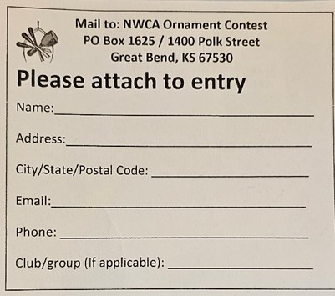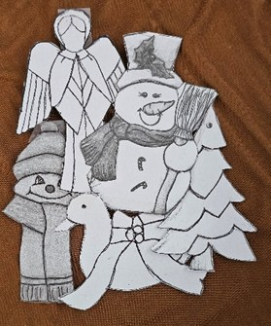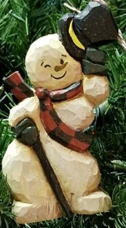
National Wood Carvers Association

Ornament entry donation or contest

Below is the entry for a Christmas Ornament to be sent to be distributed to those in need. Feel free to in-
corporate other holidays in the December timeframe. We can either have individuals enter or we may en-
ter as a club.

Michael W. has suggested vendor or club may provide planks if requested.

Contact Joyce moonbeam4mj
-
carver@yahoo.com

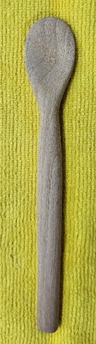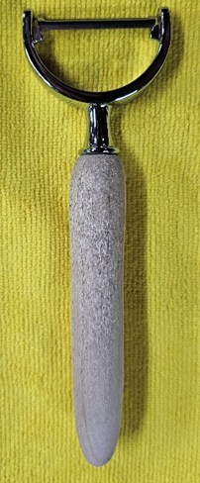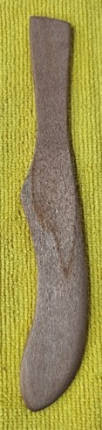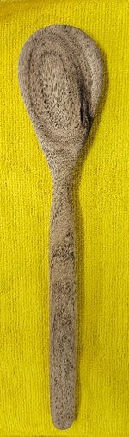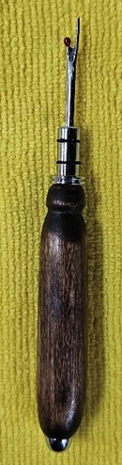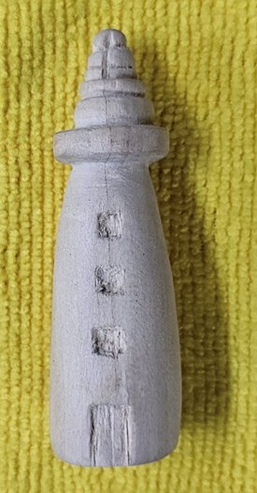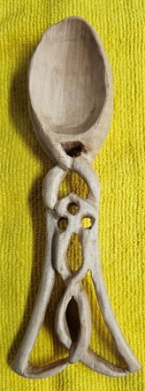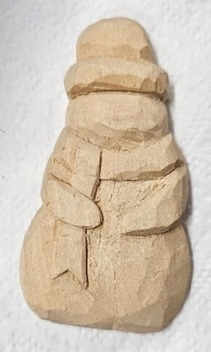
Show & Tell

The spoon pealer, spreader, seam ripper and the light house carved by beginner Bob E. Great job and glad to
have you as an active member. Keep carving and inspiring. Bob started his adventure in carving at the Pack-
ard Center beginners class.

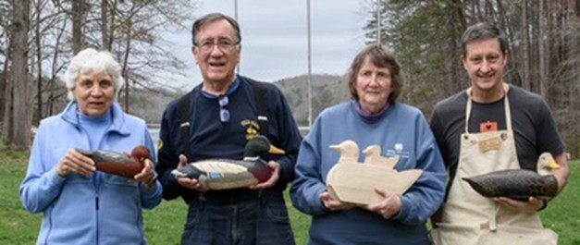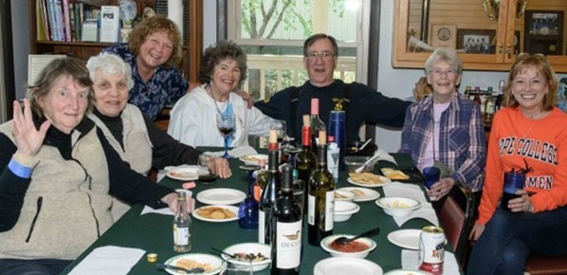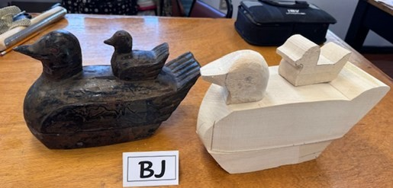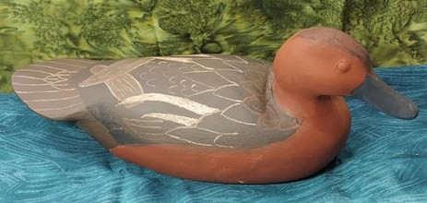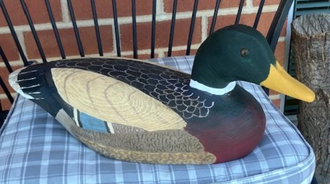
Appomattox Decoy Workshop 2025 Spring

By Mike Connors

Four members of the Northern Virginia Carvers attended the March session of Ed Morrison
’
s Decoy
Workshop at the Holiday Lake 4H Educational Center near Appomattox, VA. As usual, there was plenty
of home
-
cooked country food and lots of socializing. There was the usual bunch of carvers from Virgin-
ia, Maryland and a few neighboring states, plus a few newcomers. Ed took special care with the newbies,
and the rest of us just carved and painted and socialized.

Marc Tranchemontagne carved and painted a beautiful black duck with painstaking work to outline the
major feathers in a light gold color. BJ France worked on an unusual piece; she copied an actual antique
(
probably from colonial times) that was a box in the shape of a duck with a duckling on its back. BJ
spent most of the time on the box part of the carving, which was laborious and time
-
consuming. But now
she has a project to work on at home; completing the exterior carving. Linda Novacek carved and painted
a beautiful cinnamon teal. I carved a mallard and painted it in an Elmer Crowell paint scheme of bold col-
ors that blended well.

The decoy workshop wasn
’
t all work. There was plenty of time for socializing. Some of us made use of
the shooting range. There was a bonfire and sky
-
watching event. Also, demonstrations on burning and
antiquing decoys. s

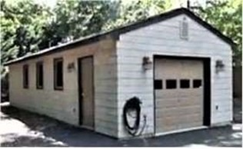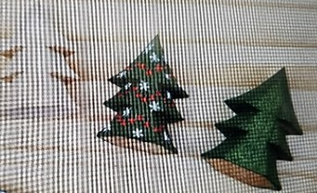
The Shed May 19, 2025 Meeting

Northern Virginia Carvers will be meeting at Ed
’
s shed.

Third Monday of the Month.

BIG THANKS TO ED DONNEN!

6518
Spring Valley Drive, Alexandria, VA 22312
–

3.4
miles from Woodcraft, Springfield.

703
-
750
-
0947
Ed Donnen

6:00
pm to 9:00 pm

PROJECT FOR MAY 19, 2025 PAINTING EXPERIENCE AND
SHARING

Main focus is to have eyelet making by Michael W. and painting. Bring your project Christmas tree or another.
Limited supplies provided. Have your piece pre
-
sealed or learn a new way that night. Contact Joyce if you
have any questions.

Light food faire will be available. Joyce
’
s treat.

NORTHERN VIRGINIA CARVERS RENEWAL
FOR JAN-DEC 2025

Name___________________________ Address:
________________________________

________________________________

________________________________

Home Phone_____________________

Cell Phone_______________________

Receive Newsletter by E-Mail?

Yes______ No_______

E-Mail___________________________

Membership Fees Per Year:

Single $25.00
Family: $25.00 + $5.00 each additional member

Additional members names:
________________________________

________________________________

Suggestions for Programs or Classes
________________________________

________________________________

________________________________

MAKE CHECK PAYABLE TO NVC AND MAIL TO:

Robert Simoniz, Membership
NORTHERN VIRGINIA CARVERS
6819 Rock Creek Court Alexandria, VA 22306

Membership in the Northern Virginia Carvers runs from January to December. Please mail your dues, which are $25.00 for a single membership and $5.00 for each additional family member along with the filled out renewal form, to Robert Simoniz, Membership Chairman, 6819 Rock Creek Court, Alexandria, VA 22306. Make check payable to NVC.

If you have changed your email, please let us know. If you used to get the newsletter by email, but recently have received mailed copies, then something is wrong with the email address we have on file for you, and your email copy bounced back. Please contact Bob Simoniz at rsim2193@veriizon.net, so he can correct the database.

Page
DEADLINE FOR JUNE NEWSLETTER ARTICLES: FRIDAY MAY 30
MEETING LOCATIONS
Woodcraft Supply — Ravensworth Shopping Center, 5248 Port Royal Road, Springfield, VA 22151. 703-912-6727.

Packard Center — 4022 Hummer Road, Annandale, VA 22003.

Richard Byrd Library – 7250 Commerce St, Springfield, VA 22150

Kings Park Library, -- 9000 Burke Lake Rd, Burke, VA 22015

Colvin Run Mill,-- 10017 Colvin Run Rd, Great Falls, VA 22066-1834

The Shed — 6518 Spring Valley Drive, Alexandria, VA 22312
 |  | NVC Contacts
President | Joyce Spieler | Chairs General Meetings and Board Meetings | Moonbeam4mj-carver@yahoo.com | 703-915-3239
Vice-President | Mark Tranchemontagne | Vice Chair of General Meetings and Board Meetings | mgtranch@yahoo.com | 703-531-9912
Treasurer | Wendy Neidermeyer | Manages Finances | knitknucklehead@gmail.com | 571-239-2105
Secretary |  | Keeps Minutes and Maintains NVC Archives
Past President | Phillip Simpson |  | eightb1045@aol.com | 703-360-9575
Colvin Mill Coordinator Joyce Spieler |  | Coordinates Carving Instruction Program at Colvin Mill Park | Moonbeam4mj-carver@yahoo.com | 703-915-3239
Show Coordinator |  | Coordinates the Annual Show & Competition
Membership Chairman and  Newsletter Editor | Bob Simoniz | Maintains membership database and collects dues Edits and publishes NVC Newsletter | rsim2193@verizon.net | 703-768-1087
Program Chairman |  | Develops New Programs for the Club
NVC Web Site | Joyce Spieler | www.northernvirginiacarvers.org | Moonbeam4mj-carver@yahoo.com | 703-915-3239
Member-at-Large  Member-at-Large  Member-at-Large | B J France  Jerry Donahoe  Michael Wine |  | bjinarl@aol.com  jrdsriding@aol.com  mdwine55@gmail.com | 703-538-4143  703-327-4022  703-368-2282
NORTHERN VIRGINIA CARVERS  6819 Rock Creek Court Alexandria, VA 22306 |  |  | Address Correction Requested

