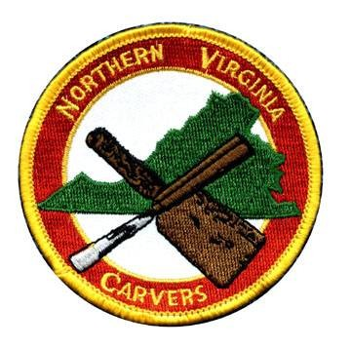
51ST ANNUAL Northern Virginia Carvers
WOODCARVING SHOW
Saturday, OCTOBER 11, 2025 10:00 am to 4:00 pm
Woodcraft Store, Ravensworth Shopping Center
5248 Port Royal Road, Springfield, VA 22151
Registration Form
Carver’s Name:________________________________________
Title of Piece:__________________________________________
Your Experience Level: ____Beginner ____Intermediate ____Advanced
Check Category:
___Carving-in-the-Round HUMAN (realistic) ___Relief Carving
___Carving-in-the-Round HUMAN (non-realistic) ___Chip Carving
___Carving-in-the-Round ANIMAL (realistic) ___CNC
___Carving-in-the-Round ANIMAL (non-realistic) ___Intarsia/Scroll Saw/Marquetry
___Carving-in-the-Round PLANT (realistic) ___Wood Turning (with carving)
___Carving-in-the-Round PLANT (non-realistic) ___Pyrography
___Carving-in-the-Round NON-LIVING

To Enter 1) PREFERRED! Mail registration form to BJ or email/text/call the info to BJ
BJ France BJinARL@aol.com BJ’s cell 703-405-2112
3027 N Florida Street, Arlington, VA 22207
Or 2) Bring form(s) with carving(s) to Woodcraft
6pm-7pm Friday (Oct. 10) or 7:30am-8:30am day-of-show
Entry Fees (per person): NVC Member pre-registration: FREE day-of-show $5
(checks or cash only) NON-NVC Member pre-registration: $5 day-of-show $10
Bring carvings to Woodcraft from 6pm-7pm Friday (Oct. 10) or 7:30am-8:30am day-of-show.
Rules:
- All entries for judging must be the work of the competitor and be primarily of wood.
- A Registration Form is required for each piece entered (ok to group entries on one form).
- Carvings must have been completed within the past 5 years.
- Carvings entered in the NVC 2024 show are not permitted.
- The NVC Competition Chairman may reject any carving they consider to be offensive.
- Decision of the judges is final.
- Ribbons will be awarded in each category and experience level.
- The judges will choose a Best of Show winner.
- Voting will be held for a People’s Choice winner.
- Carvings should remain on display until the end of the show.
Northern Virginia Carvers
Woodcarving Show
October 11, 2025

Category Descriptions

Human – Any depiction of a human form or part of a human form.

Animal – Any depiction of a non-human specimen from the animal kingdom, or any part of an animal.

Plant – Any depiction of a type of flora or object from the plant kingdom.

Non-Living – Any depiction of an object that is not or never has been a living organism.

Realistic – An attempt to make the carving an actual depiction of the chosen object.

Non-Realistic – A carving which is of an abstract, stylized or caricature nature.

Relief Carving – Described as a “picture in wood”. Generally, the carving will be raised or incised into a piece of wood to form the design or picture.

Chip Carving – The incision of a pattern or design into wood by removing a series of precise chips to form an incised design in the wood.

CNC – Carvings created using a computerized CNC machine.

Intarsia/Scroll Saw/Marquetry – Pieces that are primarily created using a scroll saw or similar tool. Included in this category are Intarsia (relief formed by individual components that are applied or inlaid together to form a pattern or picture) and Marquetry (pieces of veneer applied to form decorative designs or pictures).

Wood Turning (with carving) – Pieces prepared by turning on a lathe that will also include a surface that is shaped and/or finished with carving. This category shows the integration of the carved design with the turned form. The “Turning” is not to be judged. The carving aspect of the piece will be judged.

Pyrography (Woodburning) - Wood where the primary effect was created by woodburning.

